|  |  |
| --- | --- |
|  | **Министерство науки и высшего образования Российской Федерации**  **Федеральное государственное бюджетное образовательное учреждение**  **высшего образования**  **«Московский государственный технический университет**  **имени Н.Э. Баумана**  **(национальный исследовательский университет)»**  **(МГТУ им. Н.Э. Баумана)** |

ФАКУЛЬТЕТ «Информатика и системы управления»

КАФЕДРА «Программное обеспечение ЭВМ и информационные технологии»

**ОТЧЕТ**

*к лабораторной работе №9*

*По курсу: «Операционные системы»*

*Тема: «Обработчики прерываний»*

Студент ИУ7-66Б

Турсунов Ж.Р.

Преподаватель

Рязанова Н.Ю.

*Москва, 2021 г.*

**Часть 1: Тасклет**

**Текст программы:**

|  |
| --- |
| #include <linux/kernel.h>  #include <linux/module.h>  #include <linux/interrupt.h>  #include <linux/seq_file.h>  #include <linux/proc_fs.h>  #define IRQ_NUM 1  #define PROC_FILE_NAME "tasklet"  MODULE_LICENSE**(**"GPL"**);**  MODULE_AUTHOR**(**"Tursunov Jasurbek"**);**  static int my_dev_id**;**  const unsigned long my_tasklet_data **=** 123456**;**  static struct proc_dir_entry **\***proc_file**;**  struct tasklet_struct my_tasklet**;**  static int __init my_tasklet_init**(**void**);**  static int my_tasklet_open**(**struct inode **\***inode**,** struct file **\***file**);**  static int my_tasklet_release**(**struct inode **\***inode**,** struct file **\***file**);**  static int my_tasklet_show**(**struct seq_file **\***m**,** void **\***v**);**  static void __exit my_tasklet_exit**(**void**);**  void my_tasklet_handler**(**unsigned long data**);**  static irqreturn_t my_interrupt_handler**(**int irq**,** void **\***dev_id**);**  DECLARE_TASKLET**(**my_tasklet**,** my_tasklet_handler**,** my_tasklet_data**);**  static const struct proc_ops my_tasklet_props **=**  **{**  **.**proc_open **=** my_tasklet_open**,**  **.**proc_release **=** my_tasklet_release**,**  **.**proc_read **=** seq_read  **};**  static inline void printk_tasklet_info**(**const char**\*** prefix**)**  **{**  printk**(**KERN_INFO "/my_tasklet/ %s -state: %ld, count: %d, data: %ld\n"**,**prefix**,** my_tasklet**.**state**,** my_tasklet**.**count**,** my_tasklet**.**data**);**  **}**  static int my_tasklet_show**(**struct seq_file **\***m**,** void **\***v**)**  **{**  printk**(**KERN_INFO "/my_tasklet/ Called my_tasklet_show\n"**);**  seq_printf**(**m**,** "state: %ld\ncount: %d\ndata: %ld\n"**,** my_tasklet**.**state**,** my_tasklet**.**count**,** my_tasklet**.**data**);**  **return** 0**;**  **}**  static int my_tasklet_open**(**struct inode **\***inode**,** struct file **\***file**)**  **{**  printk**(**KERN_INFO "/my_tasklet/ Called my_tasklet_open\n"**);**  **return** single_open**(**file**,** my_tasklet_show**,** **NULL);**  **}**  void my_tasklet_handler**(**unsigned long data**)**  **{**  printk**(**KERN_INFO "/my_tasklet/ Called my_tasklet_handler\n"**);**  printk_tasklet_info**(**""**);**  **}**  static irqreturn_t my_interrupt_handler**(**int irq**,** void **\***dev_id**)**  **{**  printk**(**KERN_INFO "/my_tasklet/ Called my_interrupt_handler\n"**);**  **if** **(**irq **==** IRQ_NUM**)**  **{**  tasklet_schedule**(&**my_tasklet**);**  printk_tasklet_info**(**"In interrupt handler"**);**  printk**(**KERN_INFO "/my_tasklet/ Tasklet scheduled\n"**);**  **return** IRQ_HANDLED**;**  **}**  **else** **return** IRQ_NONE**;**  **}**  static int my_tasklet_release**(**struct inode **\***inode**,** struct file **\***file**)**  **{**  printk**(**KERN_INFO "/my_tasklet/ Called my_tasklet_release\n"**);**  **return** single_release**(**inode**,** file**);**  **}**  static int __init my_tasklet_init**(**void**)**  **{**  proc_file **=** proc_create**(**PROC_FILE_NAME**,** S_IRUGO**,** **NULL,** **&**my_tasklet_props**);**  **if** **(!**proc_file**)**  **{**  printk**(**KERN_ERR "/my_tasklet/ Error: can't create seq file\n"**);**  **return** **-**ENOMEM**;**  **}**  **if** **(**request_irq**(**IRQ_NUM**,** my_interrupt_handler**,** IRQF_SHARED**,** "my_interrupt_tasklet"**,** **&**my_dev_id**))**  **{**  printk**(**KERN_ERR "/my_tasklet/ Error: can't register irq handler\n"**);**  **return** **-**1**;**  **}**  printk**(**KERN_INFO "/my_tasklet/ Module loaded\n"**);**  **return** 0**;**  **}**  static void __exit my_tasklet_exit**(**void**)**  **{**  tasklet_kill**(&**my_tasklet**);**  free_irq**(**IRQ_NUM**,** **&**my_dev_id**);**  **if** **(**proc_file**)**  remove_proc_entry**(**PROC_FILE_NAME**,** **NULL);**  printk**(**KERN_INFO "/my_tasklet/ Module unloaded\n"**);**  **}**  module_init**(**my_tasklet_init**);**  module_exit**(**my_tasklet_exit**);** |

**Результат работы**

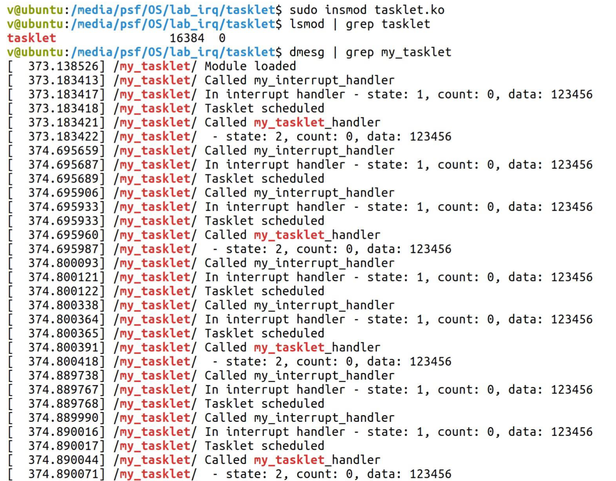

**Рис 1: Загрузка модуля**

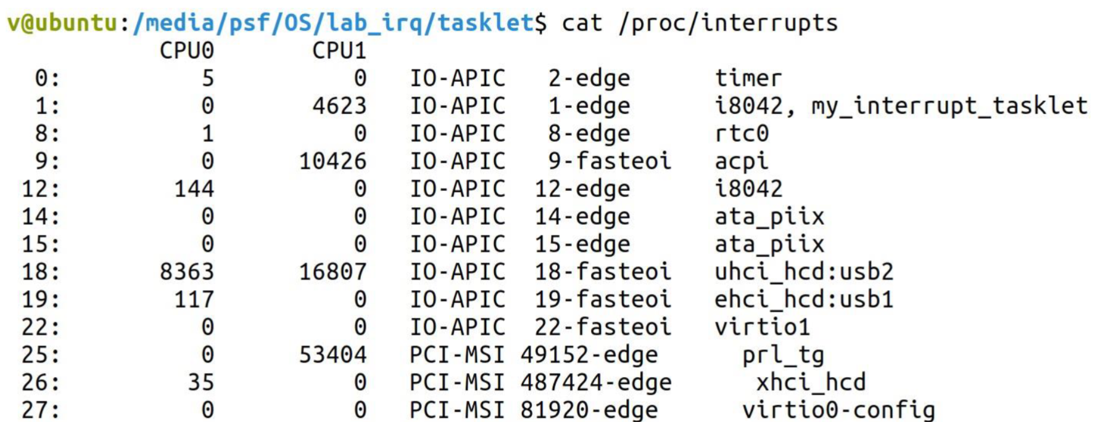

**Рис 2: Содержимое файла /proc/interrupts:**

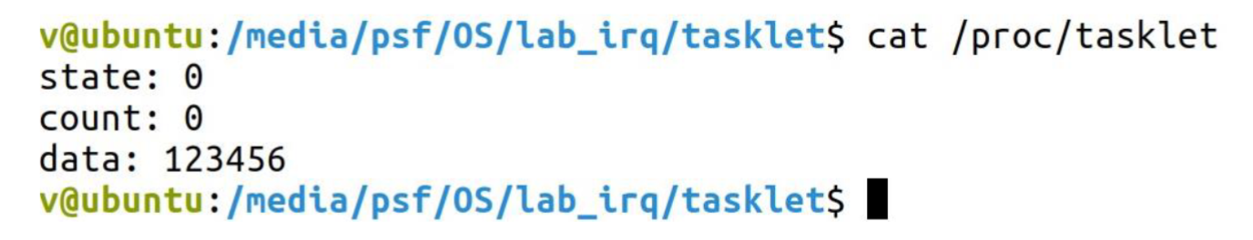

**Рис 3: Информация о тасклете в user через seqфайлы:**

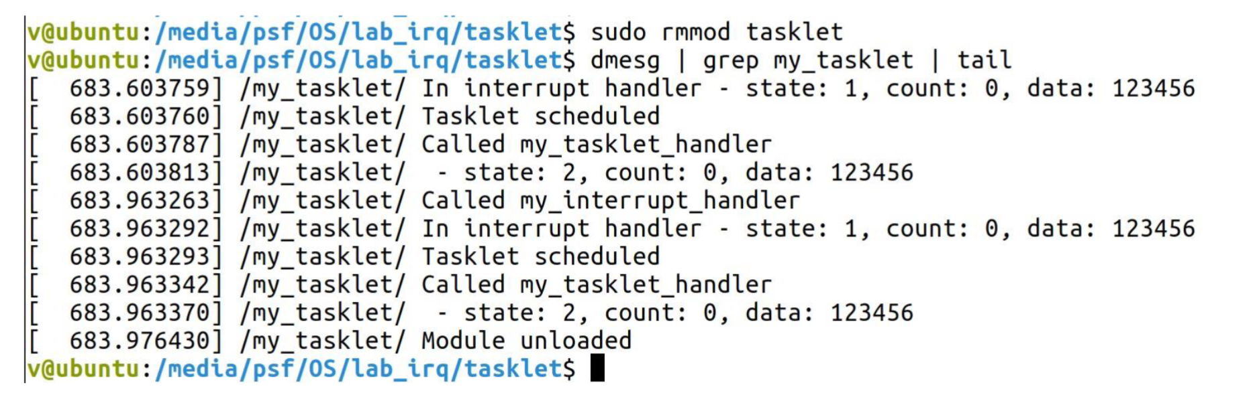

**Рис 4: Выгрузка модуля**

**Часть 2: Очередь работ**

**Текст программы:**

|  |
| --- |
| #include <linux/module.h>  #include <linux/interrupt.h>  #include <linux/workqueue.h>  #include <linux/slab.h>  #define IRQ_NUM 1  MODULE_LICENSE**(**"GPL"**);**  MODULE_AUTHOR**(**"Tursunov Jasurbek"**);**  static int my_dev_id**;**  static int irq_call_count**=** 0**;**  struct workqueue_struct **\***wq**;**  **typedef** struct  **{**  struct work_struct my_work**;**  int id**;**  int data**;**  **}**  my_work_t**;**  my_work_t **\***work1**,** **\***work2**;**  void printk_time**(**void**)**  **{**  struct timespec64 ts**;**  ktime_get_ts64**(&**ts**);**  printk**(**KERN_INFO "/my_wq/ System work time -%02lld:%02lld:%02lld\n"**,** ts**.**tv_sec **/** 3600 **%** 24**,** ts**.**tv_sec **/** 60 **%** 60**,** ts**.**tv_sec **%** 60**);**  **}**    void my_wq_function**(**struct work_struct **\***work**)**  **{**  int delay **=** 1234**;**  my_work_t **\***my_work **=** **(**my_work_t **\*)** work**;**  printk**(**KERN_INFO "/my_wq/\n/my_wq/ my_work%d.data = %d\n"**,** my_work**->**id**,** **++**my_work**->**data**);**  printk**(**KERN_INFO "/my_wq/ counter = %d\n"**,** **++**irq_call_n**);**  printk_time**();**  msleep**(**delay**);**  printk**(**KERN_INFO "/my_wq/ After %d milliseconds\n"**,** delay**);**  printk_time**();**  **}**  static irqreturn_t my_interrupt_handler**(**int irq**,** void **\***dev_id**)**  **{**  **if** **(**irq **==** SHARED_IRQ**)**  **{**  printk**(**KERN_INFO "/my_wq/ Called my_interrupt_handler\n"**);**  **if** **(**work1**)**  queue_work**(**wq**,** **&**work1**->**my_work**);**  **if** **(**work2**)**  queue_work**(**wq**,** **&**work2**->**my_work**);**  **return** IRQ_HANDLED**;**  **}**  **else**  **return** IRQ_NONE**;**  **}**  static my_work_t**\*** alloc_work**(**int id**)**  **{**  my_work_t**\***work **=** **(**my_work_t **\*)** kmalloc**(sizeof(**my_work_t**),** GFP_KERNEL**);**  **if** **(**work**)**  **{**  work**->**id **=** id**;**  work**->**data **=** 0**;**  **}**  **return** work**;**  **}**  static int __init my_wq_init**(**void**)**  **{**  **if** **(**request_irq**(**IRQ_NUM**,** my_interrupt_handler**,** IRQF_SHARED**,** "my_interrupt_wq"**,** **&**my_dev_id**))**  **{**  printk**(**KERN_ERR "/my_wq/Error: can't register interrupt handler\n"**);**  **return** **-**1**;**  **}**  wq**=** create_workqueue**(**"workqueue"**);**  **if** **(**wq**)**  **{**  printk**(**KERN_INFO "/my_wq/ Workqueue created\n"**);**  **if** **((**work1 **=** alloc_work**(**1**)))**  INIT_WORK**(&**work1**->**my_work**,** my_wq_function**);**  **else**  printk**(**KERN_ERR "/my_wq/ Error: can't initwork1\n"**);**  **if** **((**work2 **=** alloc_work**(**2**)))**  INIT_WORK**(&**work2**->**my_work**,** my_wq_function**);**  **else**  printk**(**KERN_ERR "/my_wq/ Error: can't init work2\n"**);**  **}**  **else**  **{**  free_irq**(**IRQ_NUM**,** **&**my_dev_id**);**  printk**(**KERN_ERR "/my_wq/ Error: can't create workqueue\n"**);**  **return** **-**ENOMEM**;**  **}**  printk**(**KERN_INFO "/my_wq/ Module loaded\n"**);**  **return** 0**;**  **}**  static void __exit my_wq_exit**(**void**)**  **{**  flush_workqueue**(**wq**);**  destroy_workqueue**(**wq**);**  free_irq**(**IRQ_NUM**,** **&**my_dev_id**);**  **if** **(**work1**)**  kfree**((**void **\*)**work1**);**  **if** **(**work2**)**  kfree**((**void **\*)**work2**);**  printk**(**KERN_INFO "/my_wq/ Module unloaded\n"**);**  **}**  module_init**(**my_wq_init**);**  module_exit**(**my_wq_exit**);** |

**Результат работы**

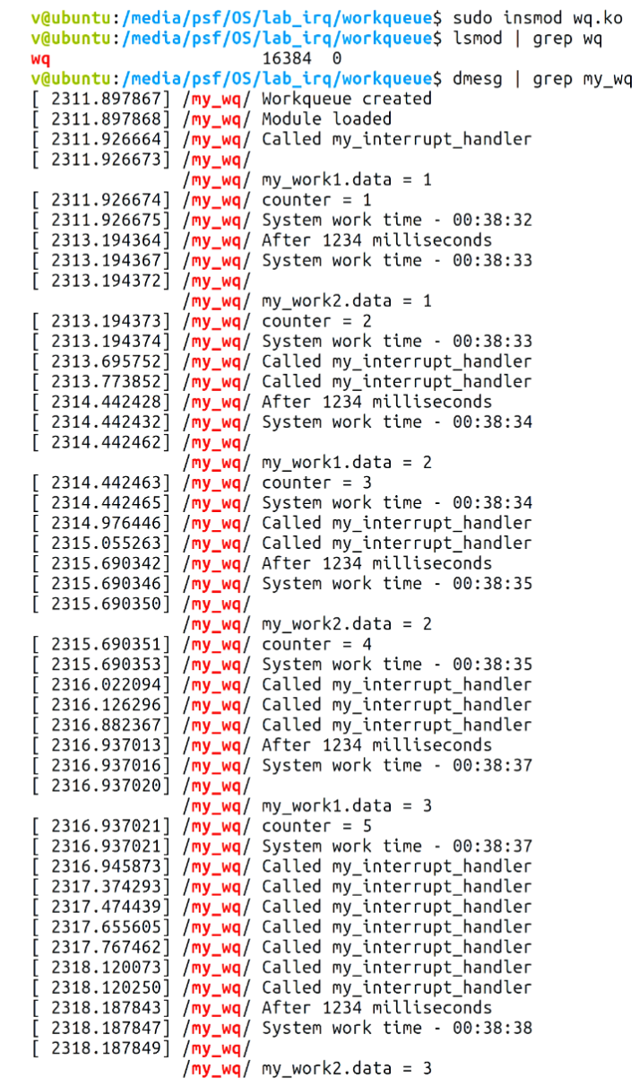

**Рис 1: Загрузка модуля**

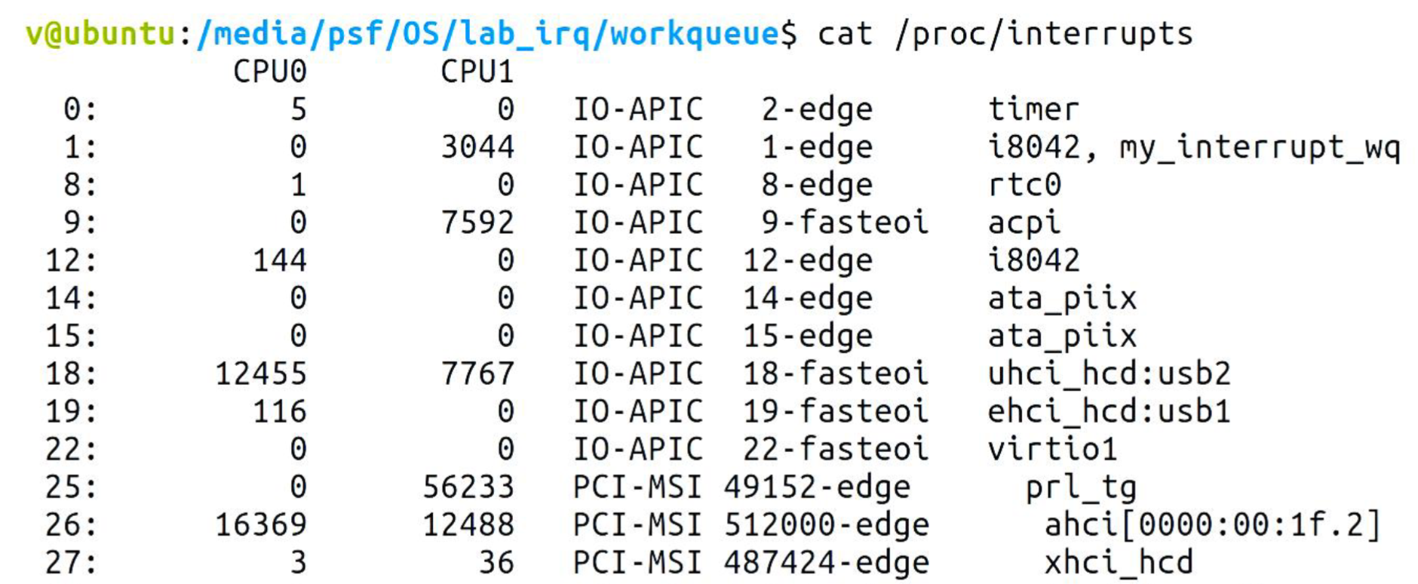

**Рис 2: Содержимое файла /proc/interrupts:**

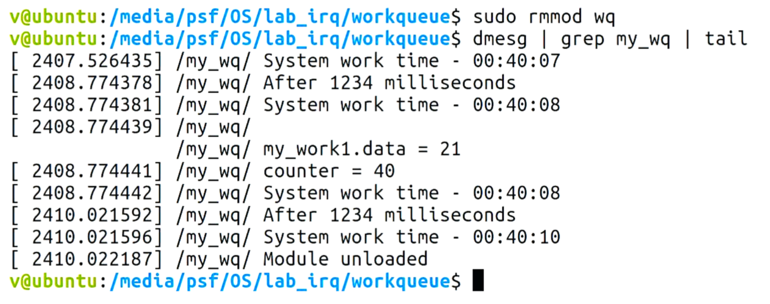

**Рис 3: Выгрузка модуля**